# 

MDWT 2008R2 Analysis Services Simple Sample

The database *MDWT2008_AS* is a very simple sample Analysis Services database, built on the Adventure Works case study. The MDWT database is similar to, but far simpler than, the *Adventure Works DW 2008R2* SSAS database provided by Microsoft on CodePlex. The MDWT version of the database is described in the book **The Microsoft Data Warehouse Toolkit for SQL Server 2008 R2**, 2011. We call this book MDWT for short.

This ReadMe describes how to install, explore, and process the MDWT version of the database. The primary purpose of these packages is to teach some principles of SSAS system design. These principles are outlined in the MDWT book (Chapter 8).

# Before You Begin

1. Install SQL Server 2008R2, including the relational database, Analysis Services, SQL Studio, and BI Development Studio (BIDS).
2. Copy the solution directories to your local machine. We keep all of the sample projects in c:\MDWT_Projects, but you should be able to put them anywhere.
3. The Analysis Services database is built from the MDWT version of the relational data warehouse: a database called MDWT_2008R2. If you worked through the Integration Services chapter (Chapter 7), and the SSIS package examples from that chapter, you should already have that database installed and populated. But if you didn’t, no worries, you can download a backup of that relational database where you found this sample. You can simply restore it to your local database server.

# Open the SSAS BIDS solution and process the database

1. Open the solution project, for example c:\MDWT_Projects\MDWT2008_AS\MDWT2008_AS.sln. This BIDS solution contains all the metadata for the definition of the SSAS cube. The solution expects the Analysis Services server and the relational server both to be installed on the local machine.
2. You can browse the cube structure even without the underlying MDWT_2008R2 relational database. But if you want to see data (and of course you do!), you’ll need to process the Analysis Services database. Within the BIDS solution, right-click on the top-level object corresponding to the database, and choose Process… as illustrated below.

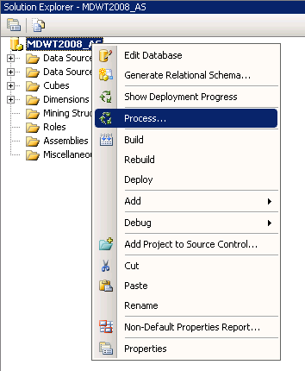

1. If you get errors, check the connection defined in the data source. Make sure it can find the MDWT_2008R2 database described previously.

# Further Exploration

The MDWT2008_AS sample database is painfully simple. In some ways that makes it a good place to start. Poke around the dimensions, to see if you understand how and why they were set up as they are. Look at the attribute relationships. Browse each of the dimensions.

It’s pretty easy to see changes that I made from the defaults that come out of the wizard: in the properties pane for an element (such as a dimension or attribute), an edited property shows up in bold type. Do you understand why some attributes have AttributeHierarchyEnabled=False? Why others have AttributeHierarchyVisible=False? Do you understand why we set up some attributes (such as [Product].[Product Category] to have a name column that’s different from the key column? Can you find some attributes that have a multi-part key (look in the Customer dimension)? Why did we set up these attributes with multi-part keys? All of these questions are answered in the text of Chapter 8.

Try creating new copies of a few of the dimensions from scratch (I always use the Product dimension).

Add some more calculations to the cube.

Don’t forget to look at the sample database provided by the SQL Server team, which you can download from CodePlex. The Analysis Services sample database is called *Adventure Works DW 2008R2*, and it’s notable for its inclusion of every single SSAS feature. It’s significantly more complicated than our sample database, so it’s a bit overwhelming at first. But it’s really more interesting and instructive, once you have a little experience under your belt.